Q1

# A

|  |
| --- |
| precision recall f1-score support |
|  |
| 0 0.73 0.50 0.59 22 |
| 1 0.31 0.75 0.44 16 |
| 2 0.33 0.09 0.14 22 |
|  |
| avg / total 0.47 0.42 0.39 60 |

# B

|  |
| --- |
| Weights |
| [[ 0.548245 0.27204046 -0.42231032] |
| [ 0.1306246 -0.03078182 0.42528832] |
| [-0.2152354 1.1112874 0.22454686] |
| [-1.5296603 1.0744767 -0.1260278 ] |
| [ 0.18507278 0.06994271 0.00728139]] |
| Bais |
| [-0.27696243 -0.32389852 0.3259599 ] |

Q2

# A

|  |
| --- |
| 0,1,2,3,4 |
| Test loss: 1.074364193280538 |
| Test accuracy: 0.4666666666666667 |
| precision recall f1-score support |
|  |
| 0 0.63 0.55 0.59 22 |
| 1 0.33 0.75 0.46 16 |
| 2 0.80 0.18 0.30 22 |
|  |
| avg / total 0.61 0.47 0.45 60 |

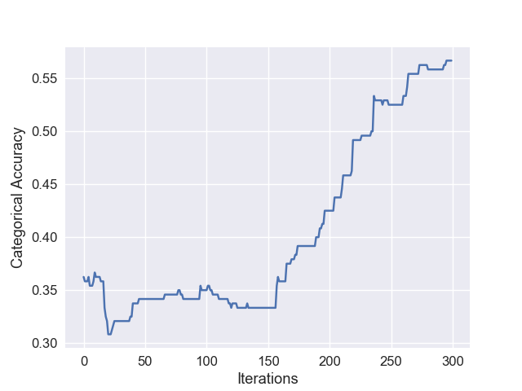

|  |
| --- |
| 0,2,3,4 |
| Test loss: 1.0811226924260458 |
| Test accuracy: 0.26666666666666666 |
| precision recall f1-score support |
|  |
| 0 0.56 0.23 0.32 22 |
| 1 0.17 0.44 0.25 16 |
| 2 0.40 0.18 0.25 22 |
|  |
| avg / total 0.40 0.27 0.28 60 |

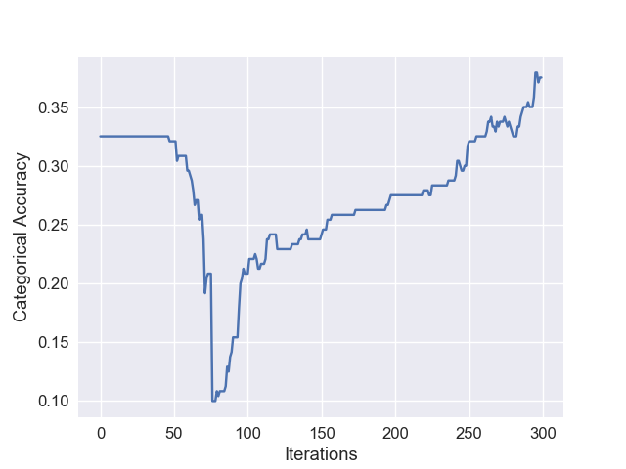

|  |
| --- |
| 0,1,3,4 |
| Test loss: 1.0846971035003663 |
| Test accuracy: 0.31666667262713116 |
| precision recall f1-score support |
|  |
| 0 0.80 0.18 0.30 22 |
| 1 0.23 0.56 0.33 16 |
| 2 0.38 0.27 0.32 22 |
|  |
| avg / total 0.49 0.32 0.31 60 |

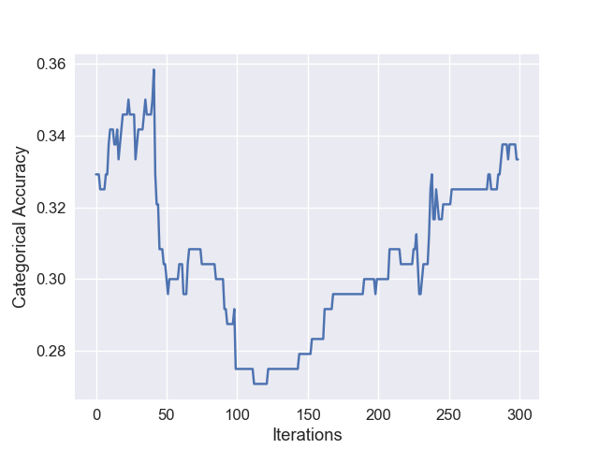

|  |
| --- |
| 0,1,2,4 |
| Test loss: 1.076397212346395 |
| Test accuracy: 0.3999999940395355 |
| precision recall f1-score support |
|  |
| 0 0.48 0.59 0.53 22 |
| 1 0.30 0.38 0.33 16 |
| 2 0.38 0.23 0.29 22 |
|  |
| avg / total 0.40 0.40 0.39 60 |

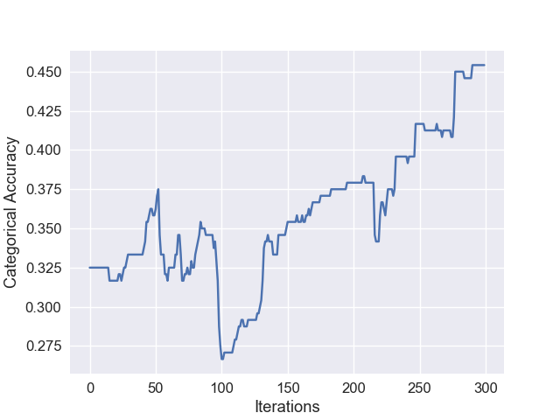

|  |
| --- |
| 0,1,2,3 |
| Test loss: 1.0867729425430297 |
| Test accuracy: 0.33333332935969034 |
| precision recall f1-score support |
|  |
| 0 0.48 0.59 0.53 22 |
| 1 0.24 0.44 0.31 16 |
| 2 0.00 0.00 0.00 22 |
|  |
| avg / total 0.24 0.33 0.28 60 |

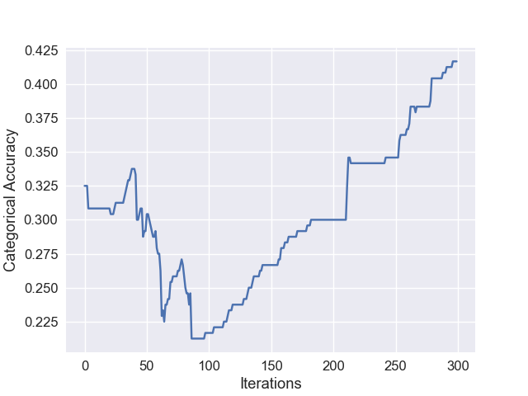

|  |
| --- |
| 1,2,3,4 |
| Test loss: 1.103313644727071 |
| Test accuracy: 0.4166666607062022 |
| precision recall f1-score support |
|  |
| 0 0.41 0.32 0.36 22 |
| 1 0.40 0.38 0.39 16 |
| 2 0.43 0.55 0.48 22 |
|  |
| avg / total 0.41 0.42 0.41 60 |

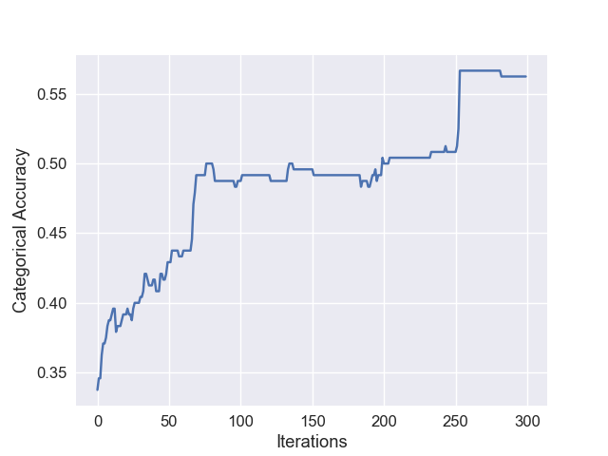

# B

|  |
| --- |
| Weights |
| [[ 0.14807387 -0.70133805 -0.6332454 ] |
| [-1.4158134 0.8559579 0.15834475] |
| [-0.09882168 0.23407479 0.43467313] |
| [-0.5402569 -0.6057765 -0.3221087 ]] |
| Bais |
| [-0.16933848 0.20169784 -0.13233076] |

Q3

|  |
| --- |
| precision recall f1-score support |
|  |
| 0 0.64 0.64 0.64 22 |
| 1 0.58 0.69 0.63 16 |
| 2 0.89 0.77 0.83 22 |
|  |
| avg / total 0.72 0.70 0.71 60 |